**Name - Gaurang A Raorane Roll No - 49**

**Class - D15A Batch - C**

**EXPERIMENT 5**

**Aim:-** To understand how to Encrypt long messages using various modes of operation using AES or DES.

**Theory:-**

It stands for Advanced Encryption Standard, developed in 2001. As triple-DES was found to be slow, AES was created and is six times faster than the triple DES. It is one of the most widely used symmetric block cipher algorithms used nowadays. It works on bytes rather than bits.

It stands for Data Encryption Standard, developed in 1977. It is a multi-round cipher that divides the full text into 2 parts and then works on each part individually. It includes various functionality such as Expansion, Permutation, and Substitution, XOR operation with a round key.

**Advanced Encryption Standard:-**

**Electronic Code Book:-**

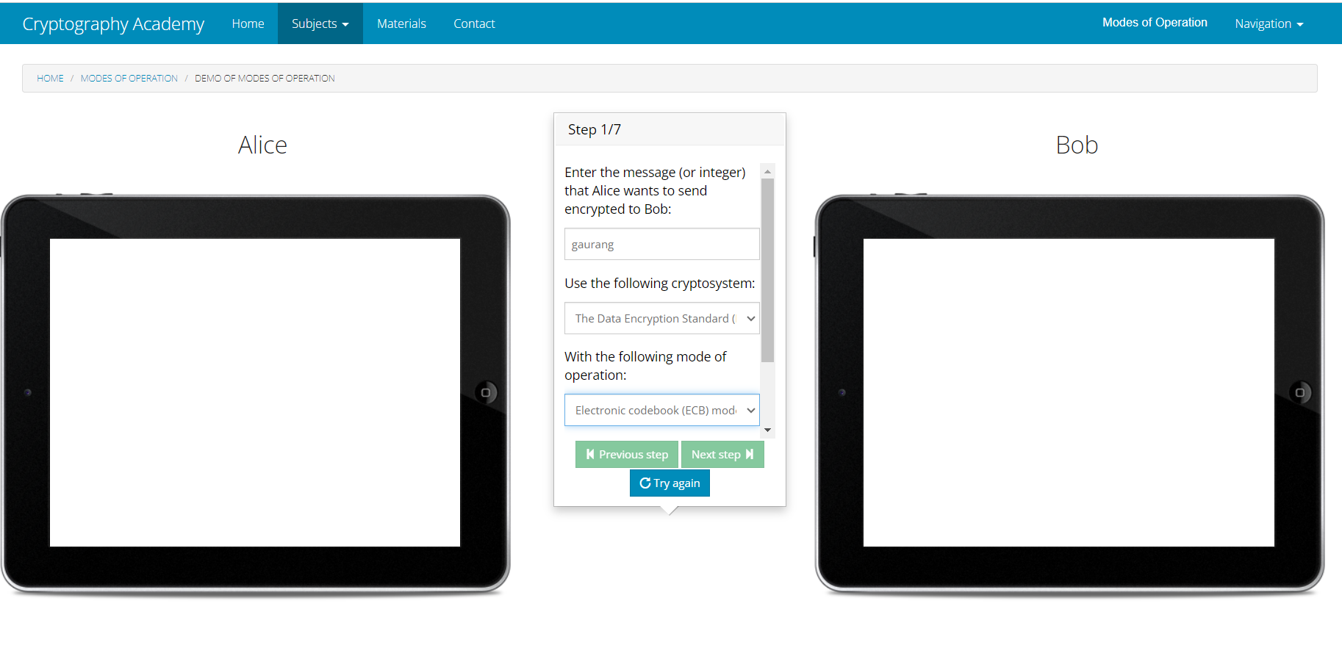

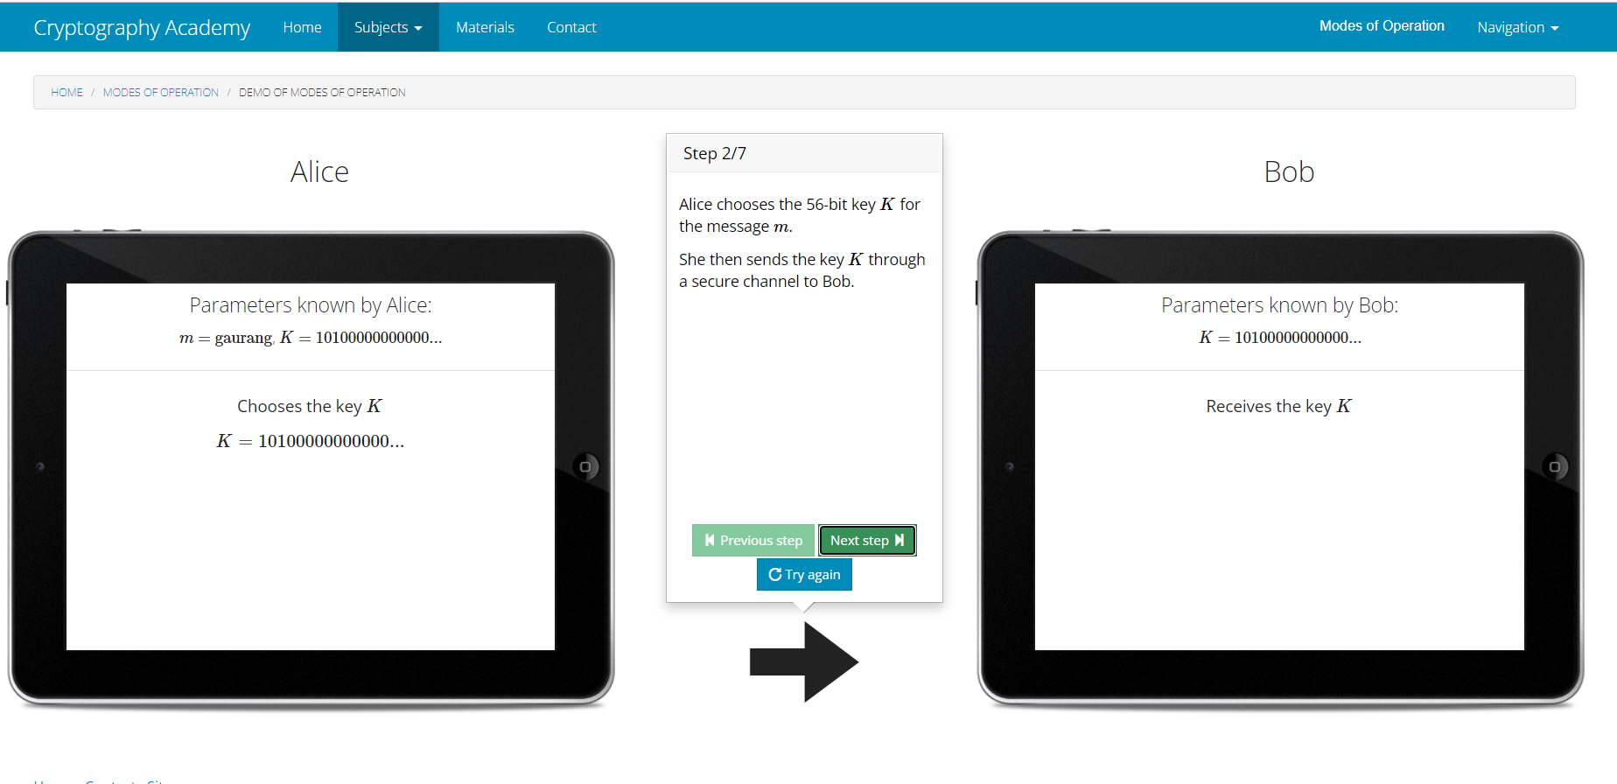

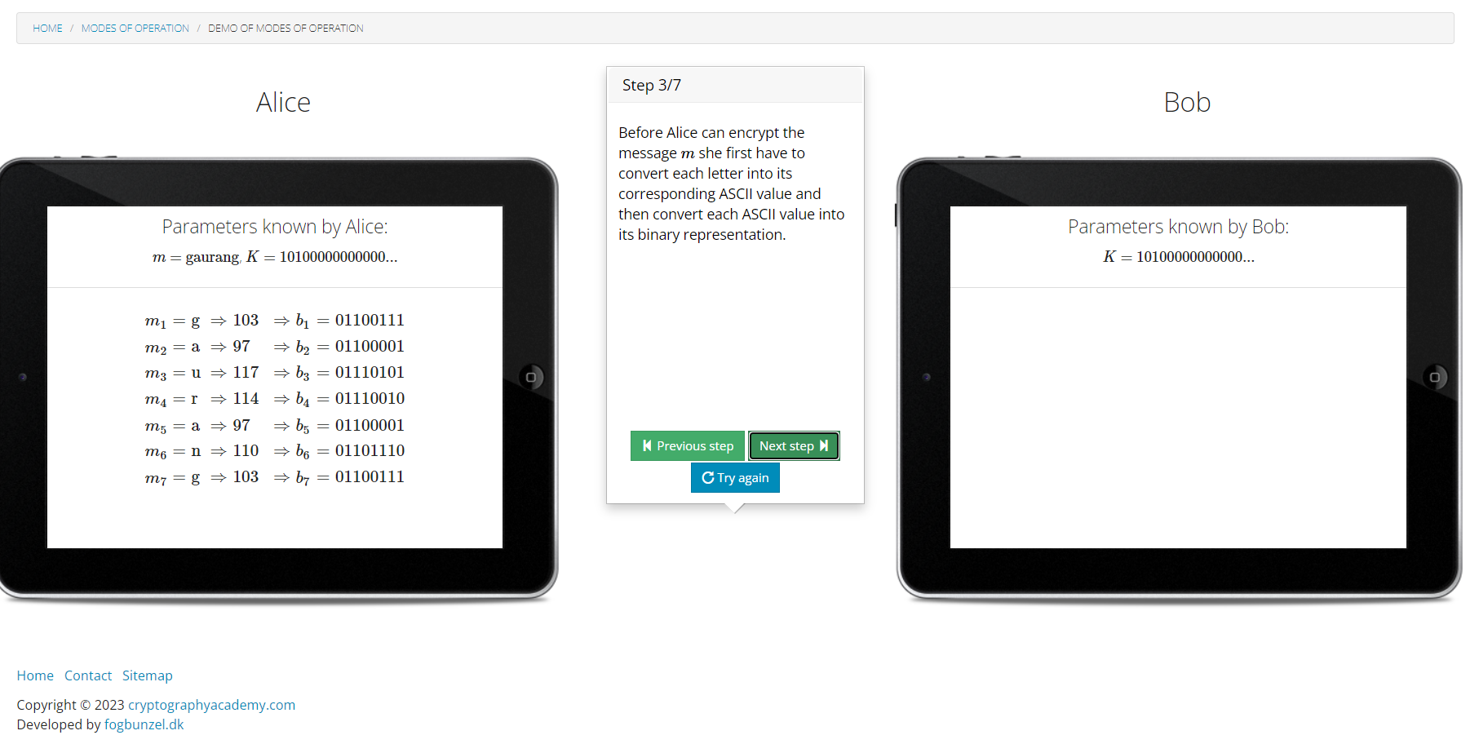

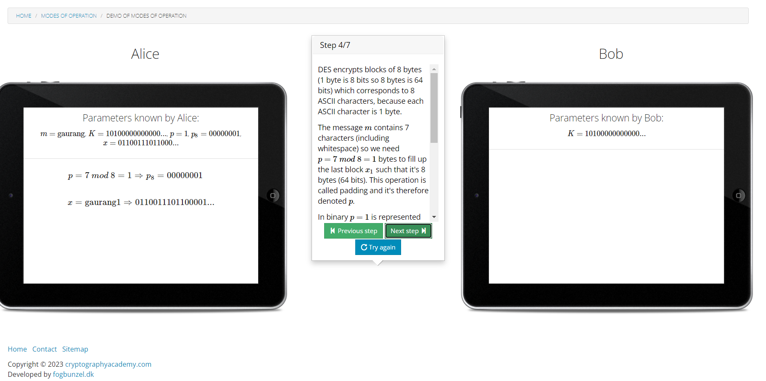

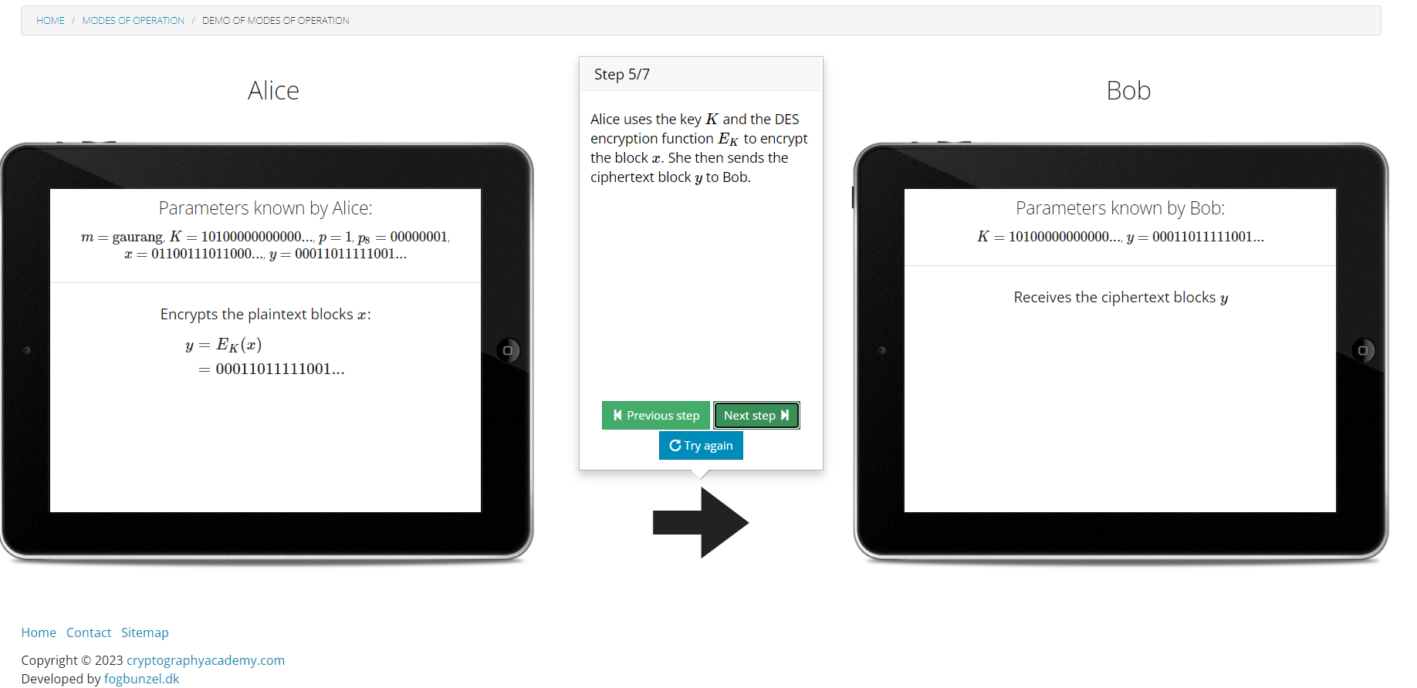

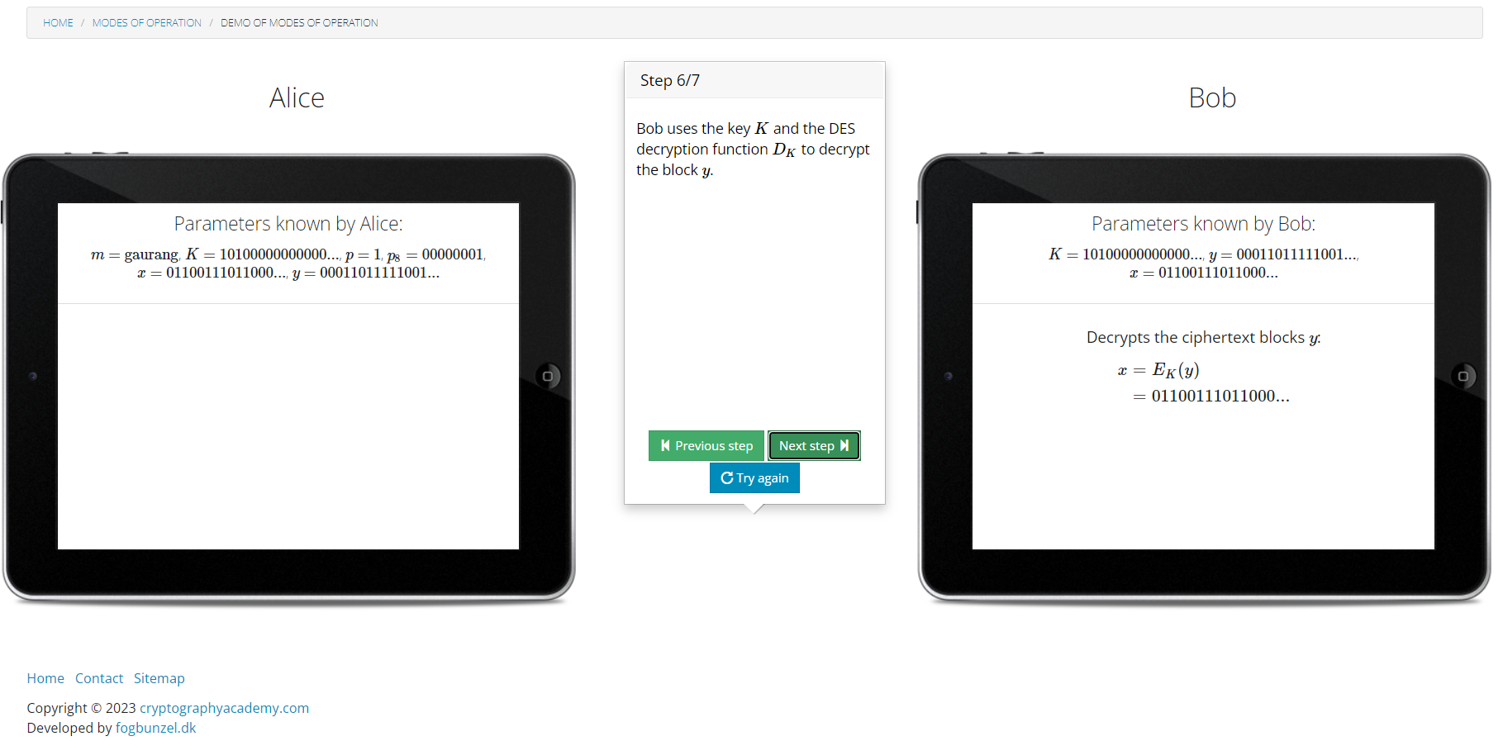

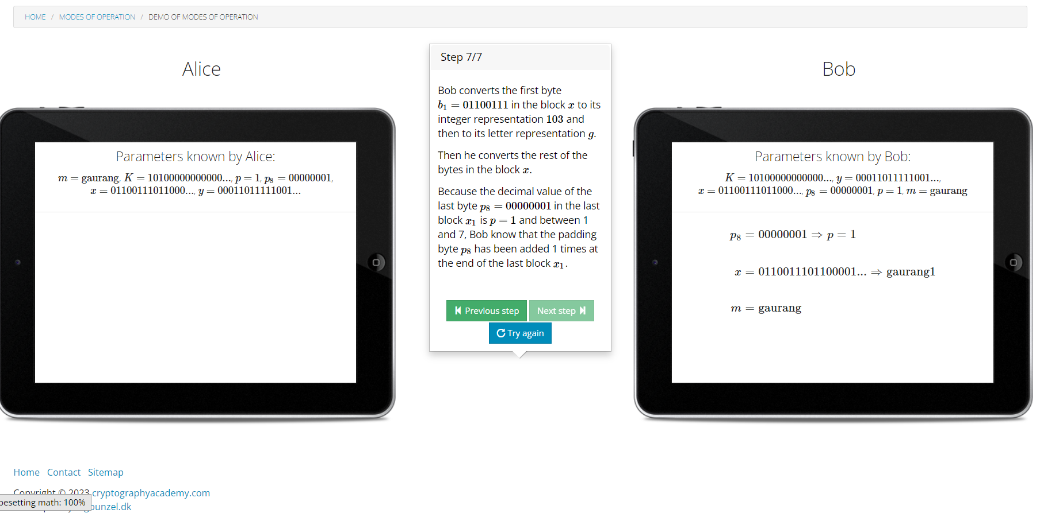

**Cipher Block Chaining :-**

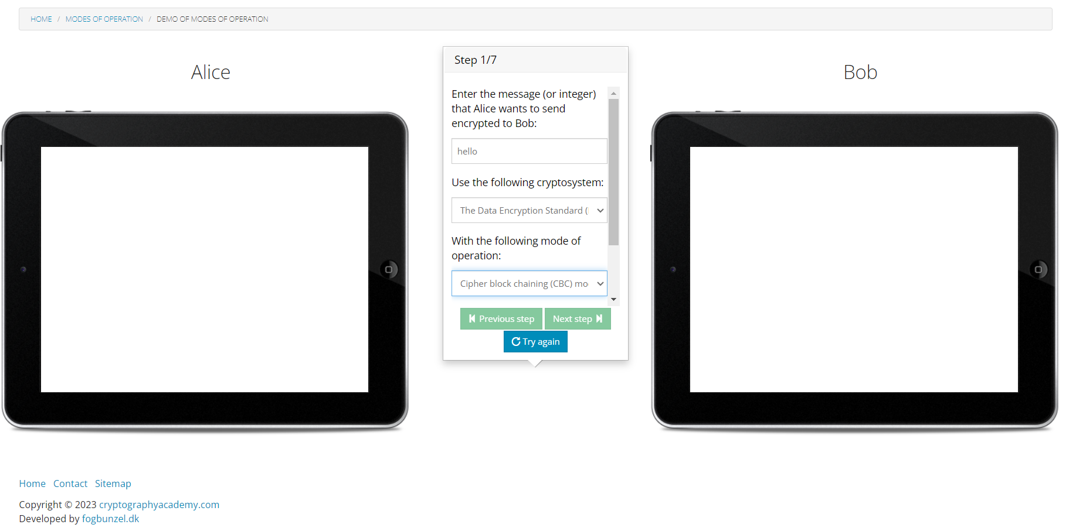

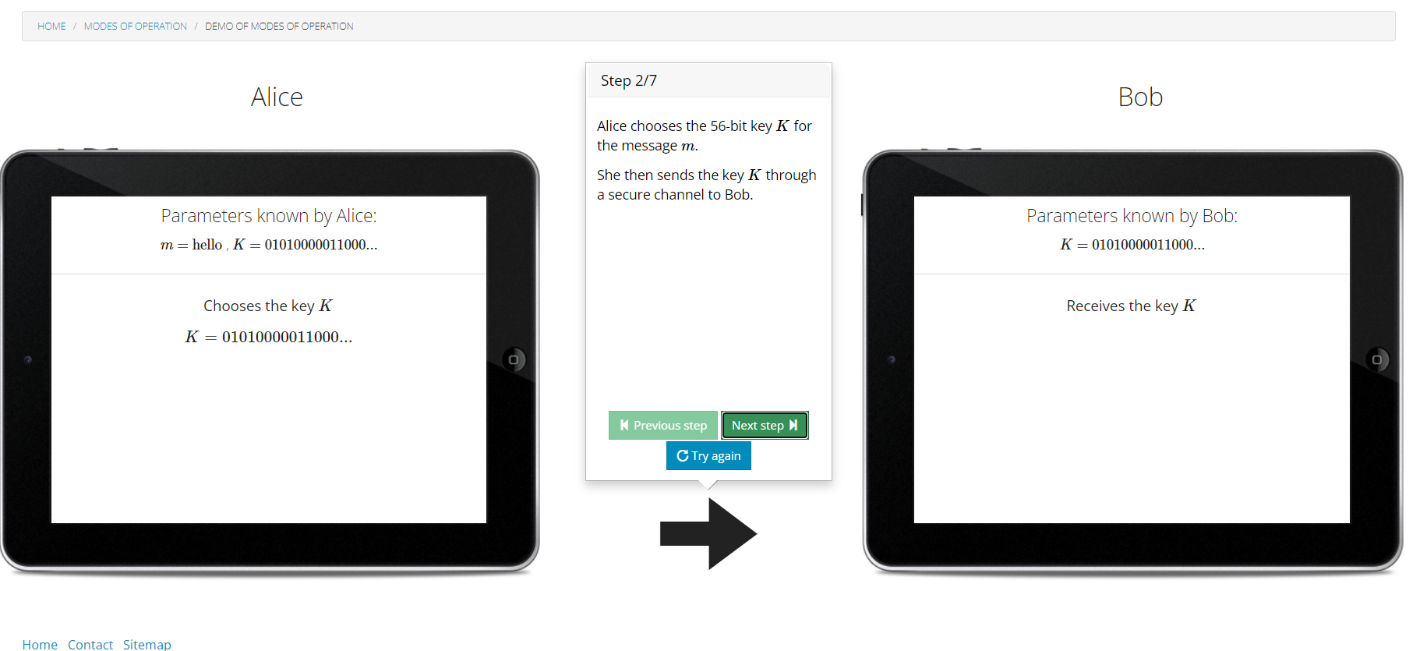

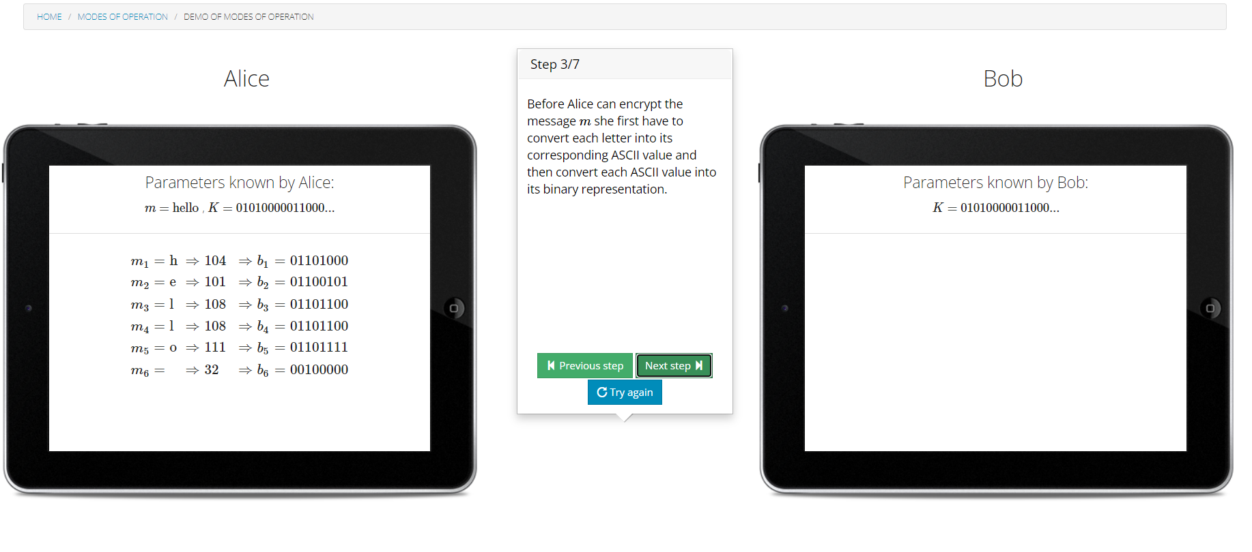

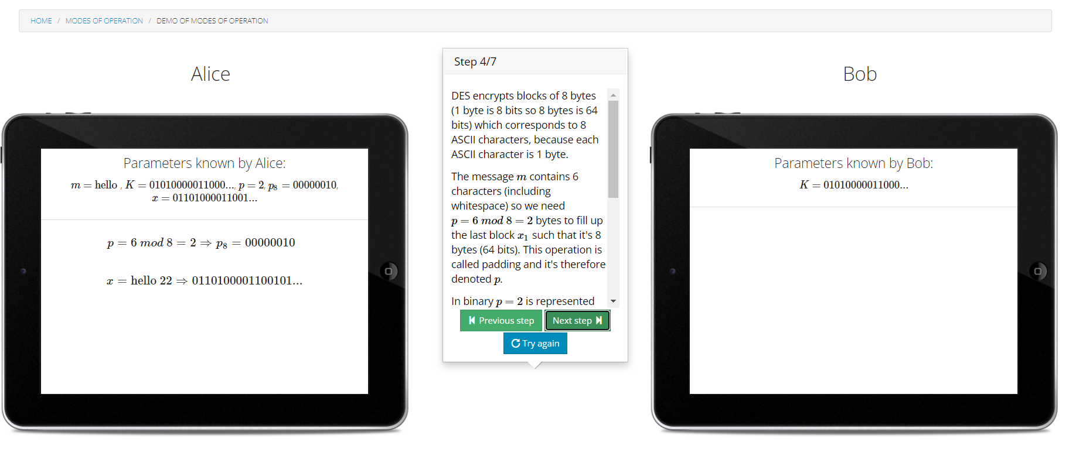

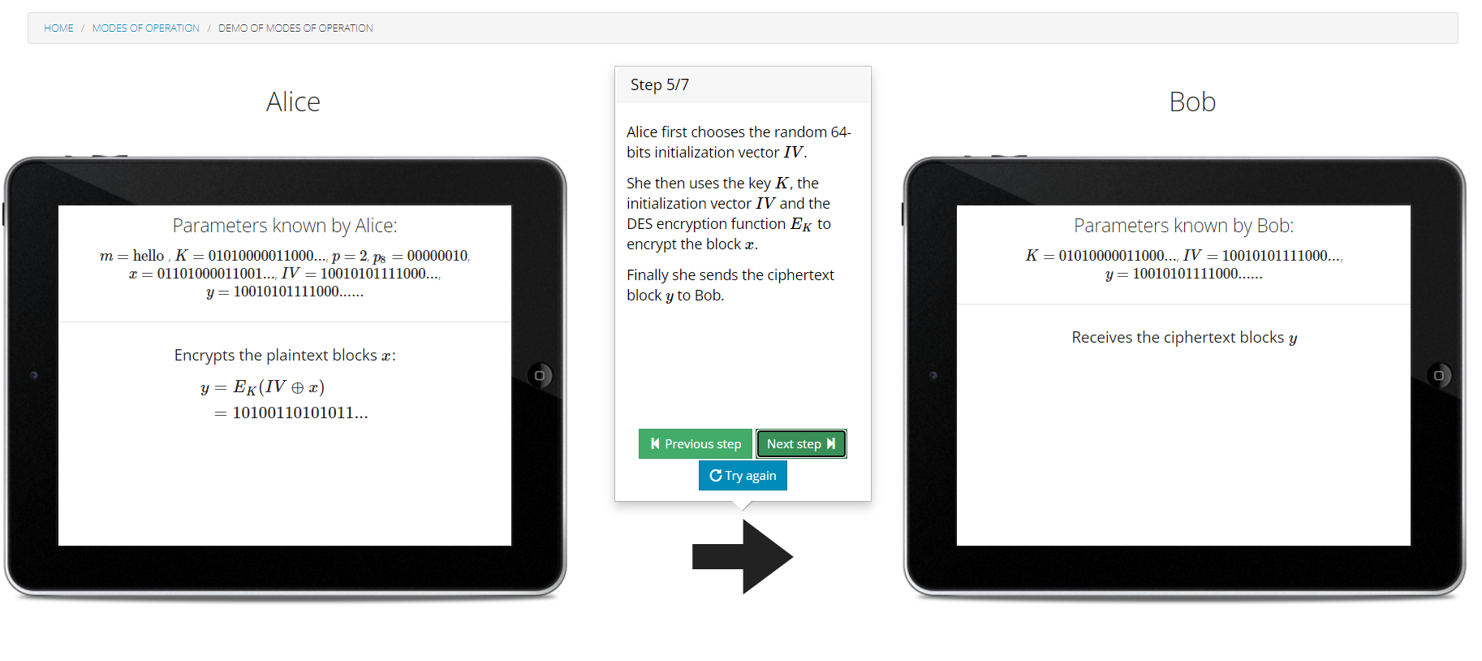

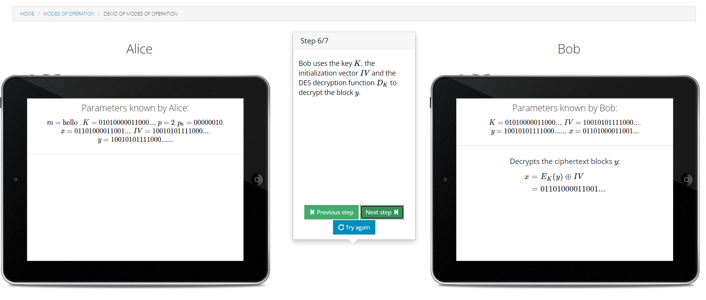

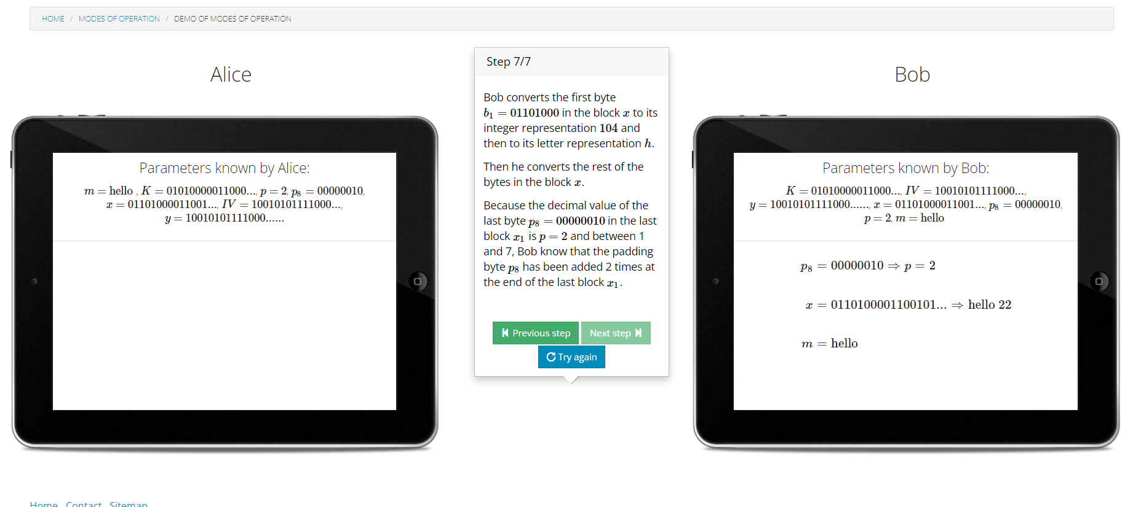

**Data Encryption Standard:-**

**Output Feedback Code:-**

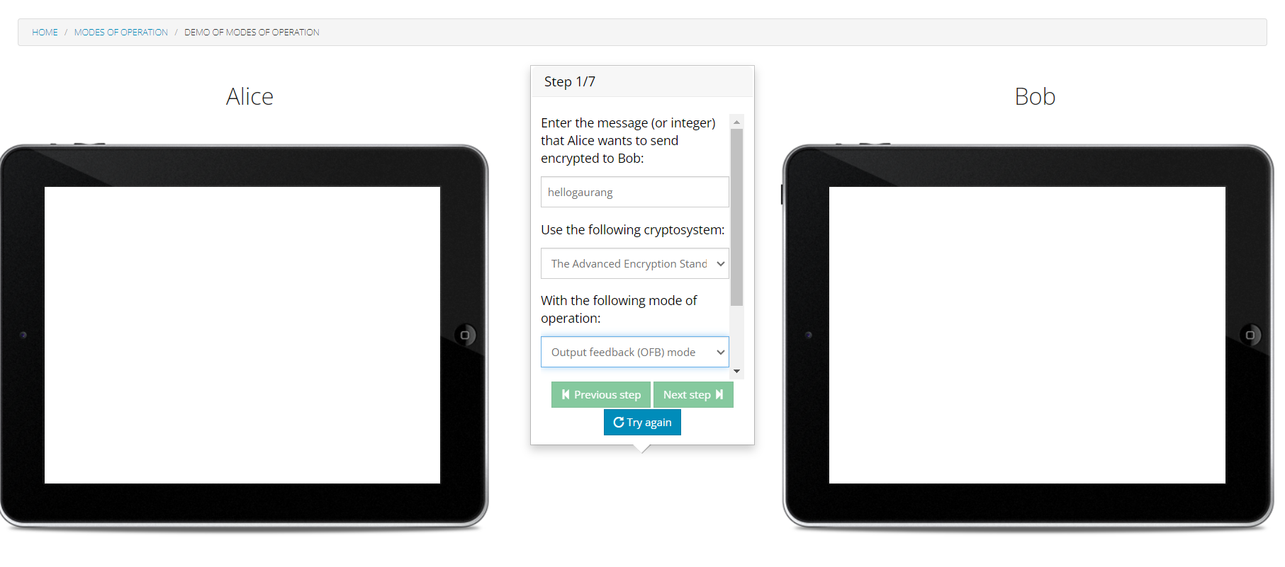

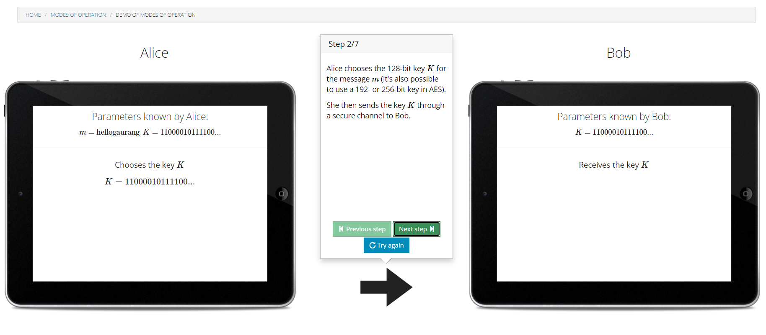

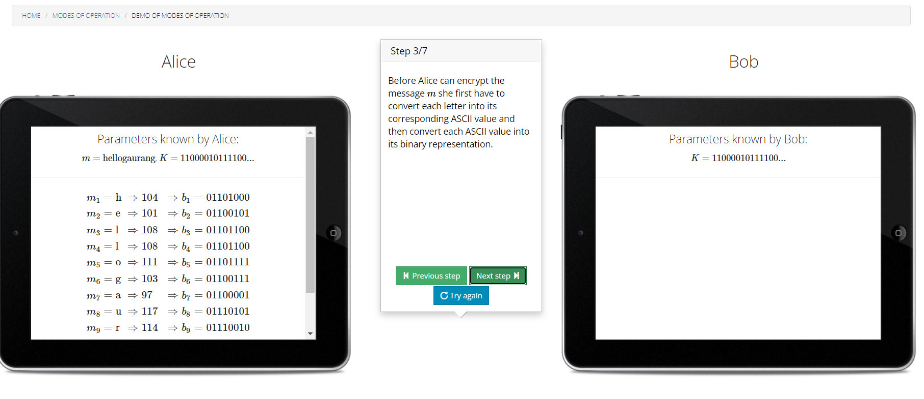

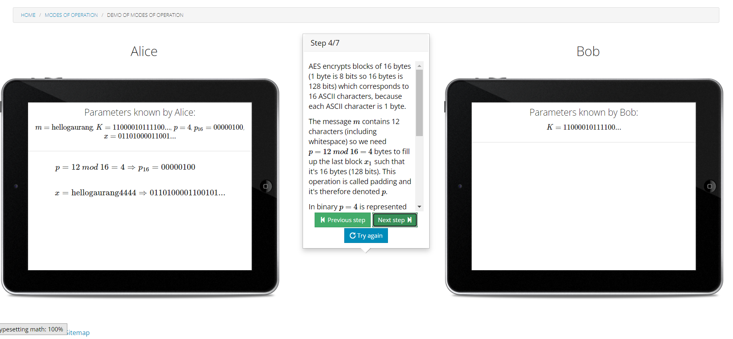

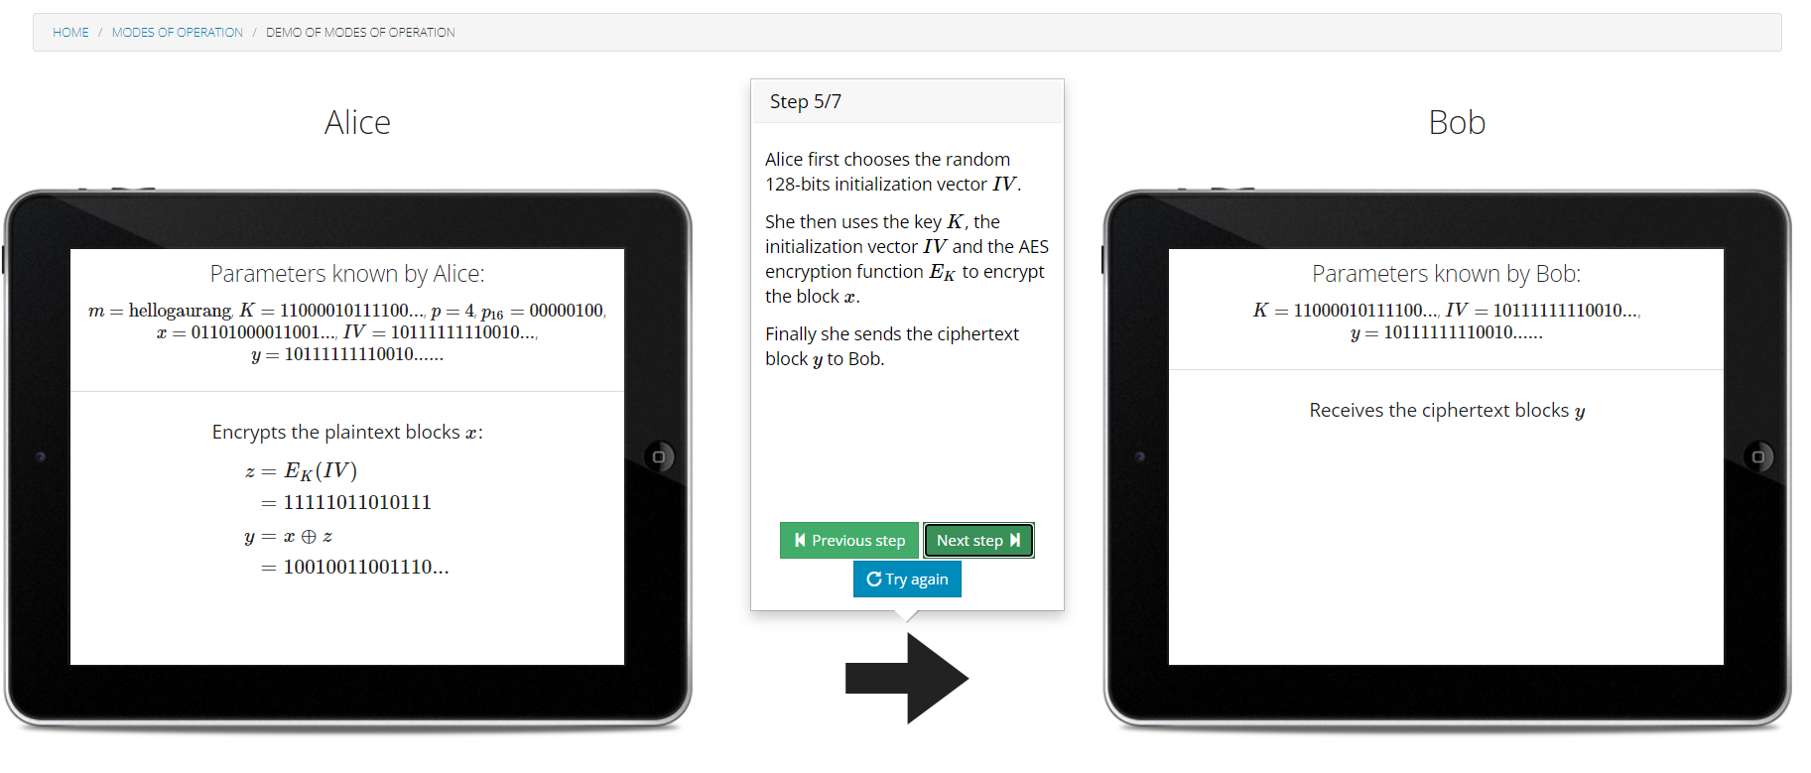

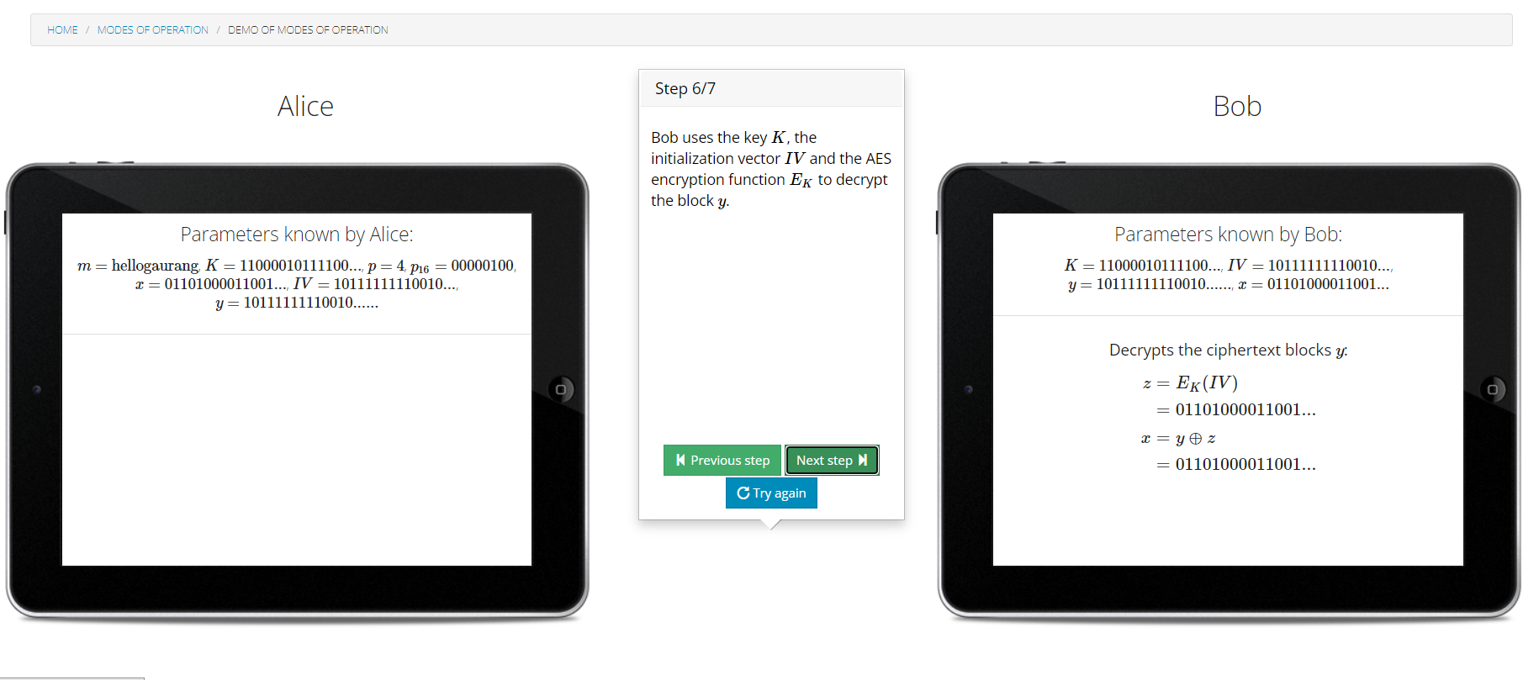

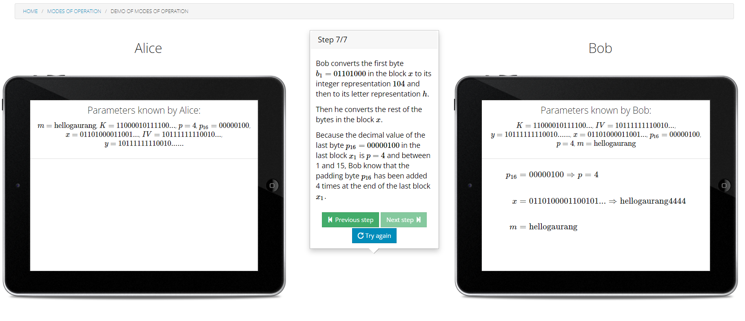

**Counter Mode:-**

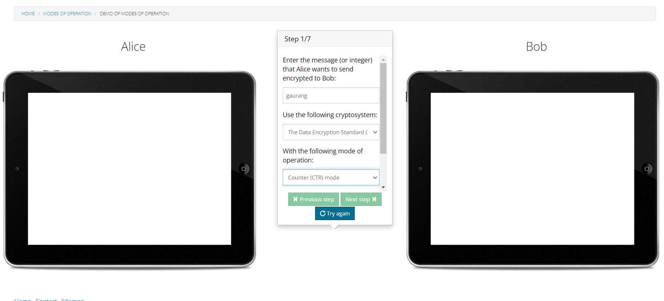

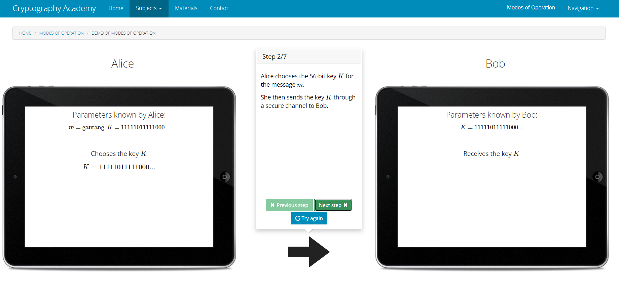

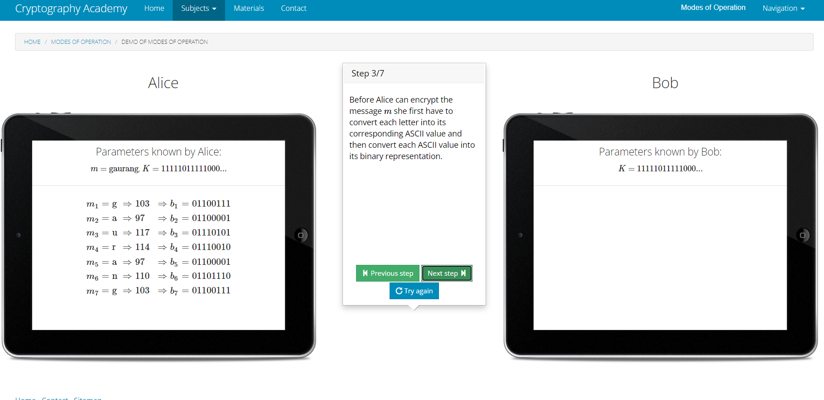

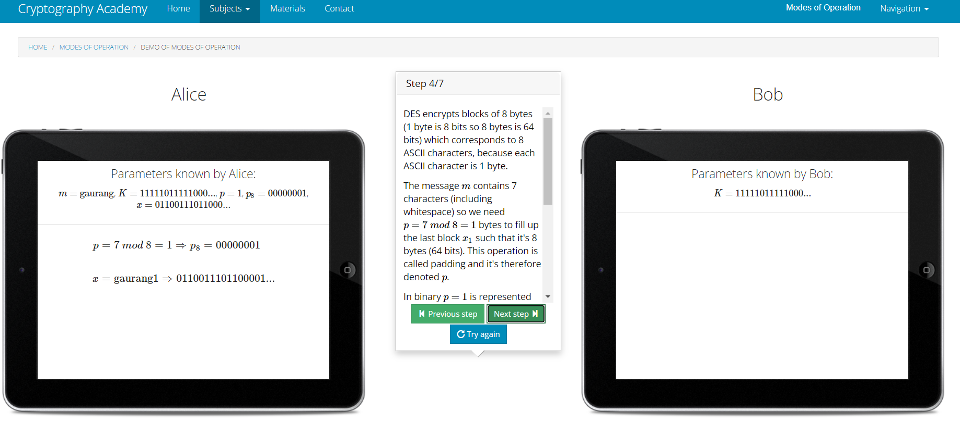

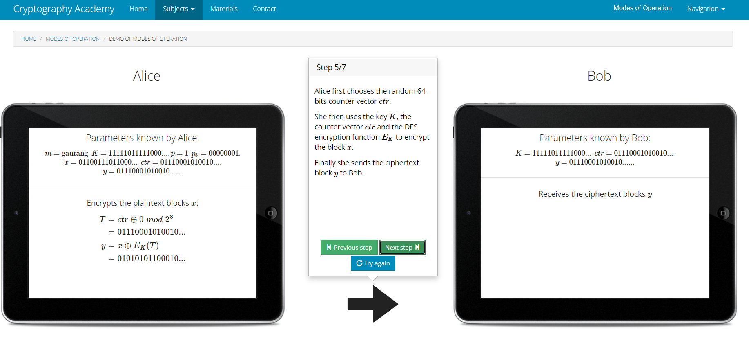

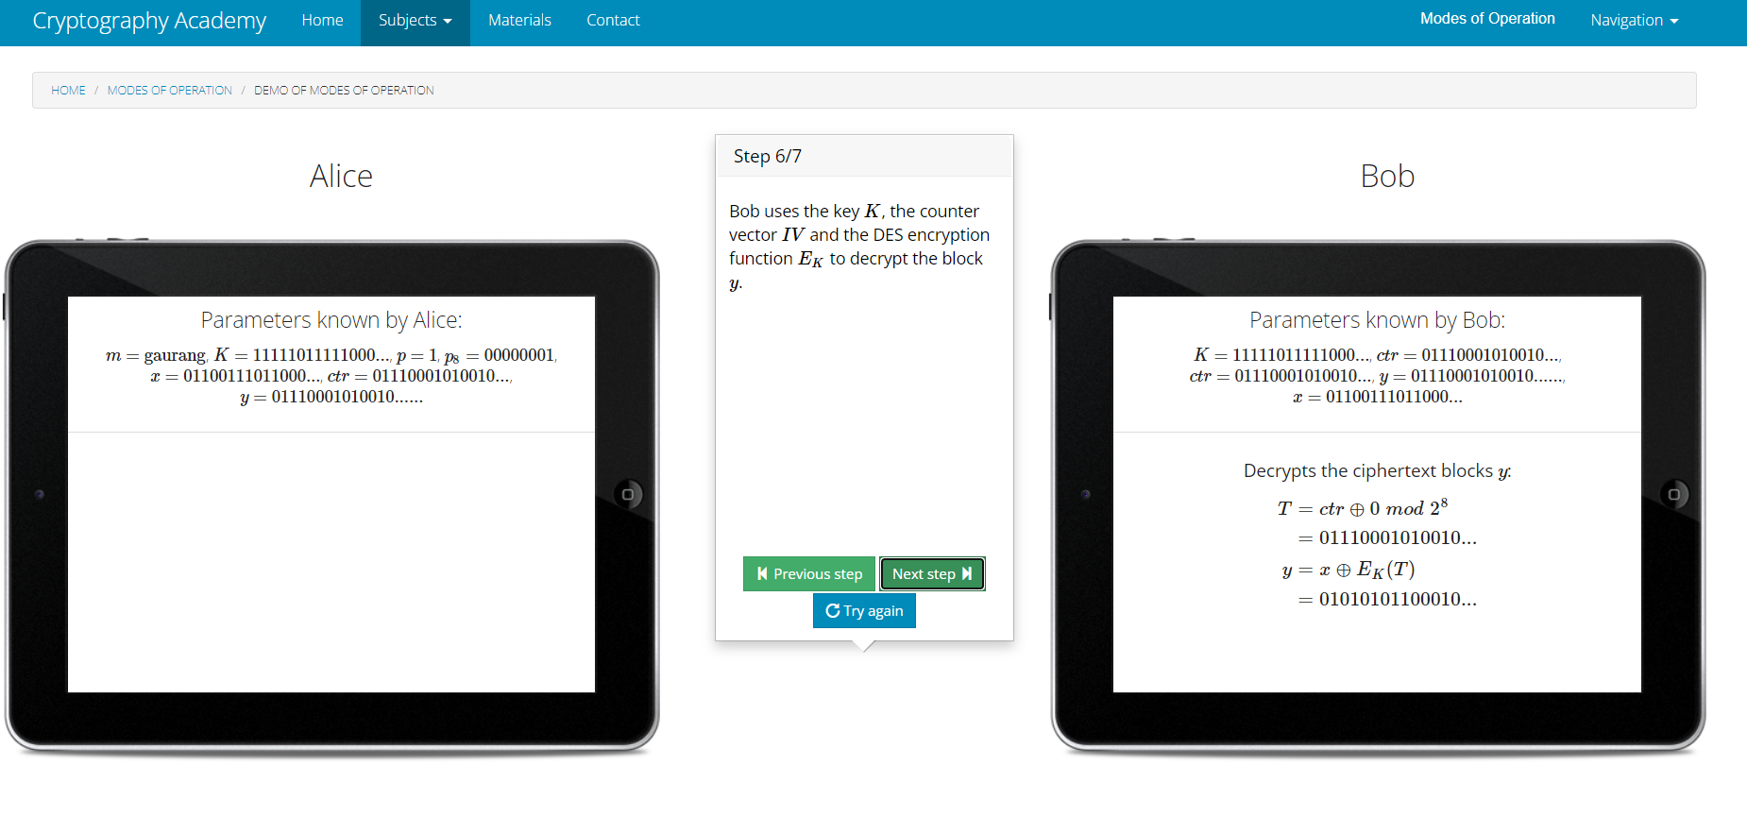

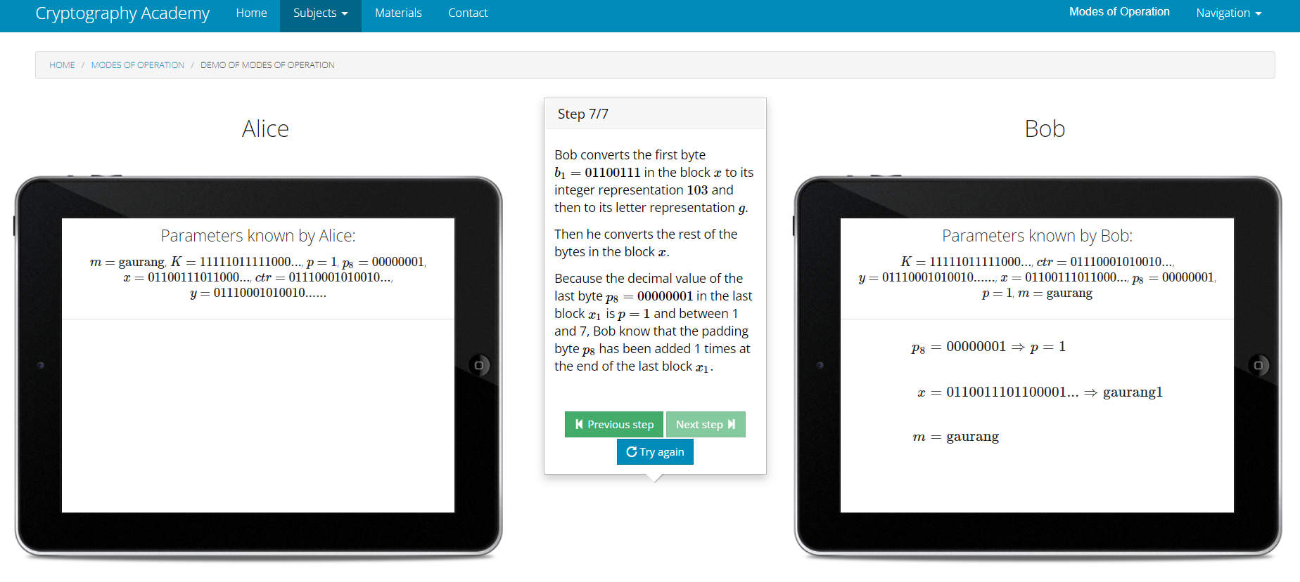

**Conclusion:-** Various modes of Aes and Des are performed successfully.

For AES Electronic Code Book and Counter Block Chaining are used.

For DES Counter and Output Feedback mode is used.